Phase 5: Apex Programming (Developer)

1. Introduction
Phase 5 focuses on extending Salesforce functionality using Apex code to implement complex business logic, automate processes, and handle integration scenarios.
Objectives:
- Develop Apex classes and triggers to process Partner Orders, Products, and Inventory.
- Handle bulk operations, asynchronous processing, and exceptions.
- Create test data and ensure proper coverage with Test Classes.
- Enable REST API endpoints for external systems.

2. Apex Classes
The following Apex classes were developed in the project:
Class Name | Purpose
OrderService | Core logic for creating and managing orders within Salesforce.
ProductService | Handles product-related operations such as price updates.
PartnerOrderService | Exposes a REST API endpoint for partners to create orders externally.
PartnerProductService | Provides product and inventory data to external systems via REST.
Key highlights:
- PartnerOrderService exposes /partner/v1/orders REST endpoint using @RestResource.
- Accepts JSON payloads containing distributorId and line items.
- Validates inventory, calculates totals, creates Partner_Order__c and Order_Line_Item__c records.
- Updates inventory quantities after successful order creation.
- Handles invalid payloads and returns appropriate HTTP status codes (400, 201).
Screenshot Suggestion: VS Code → Explorer → force-app/main/default/classes → Highlight all Apex classes.
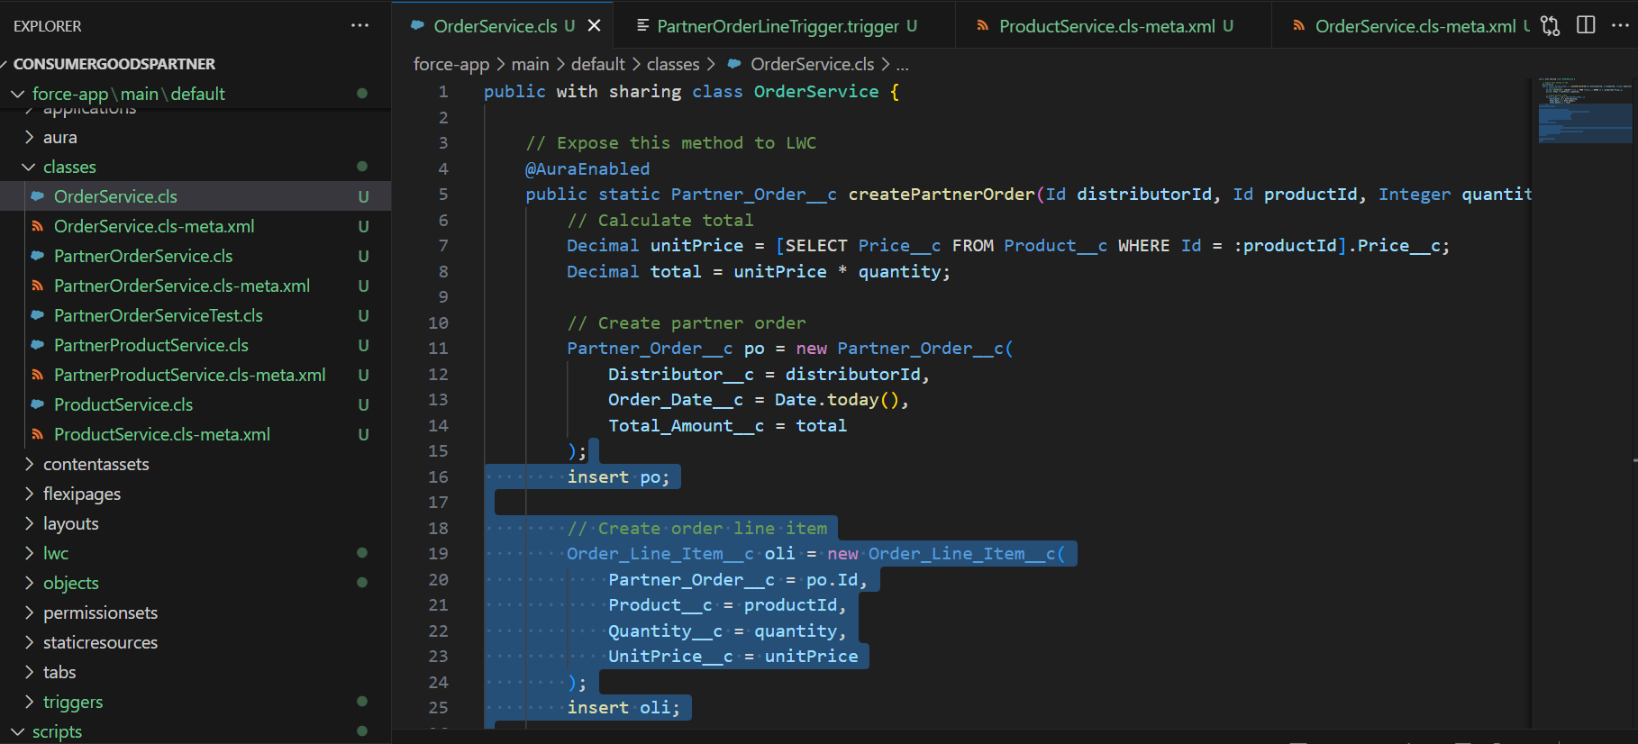
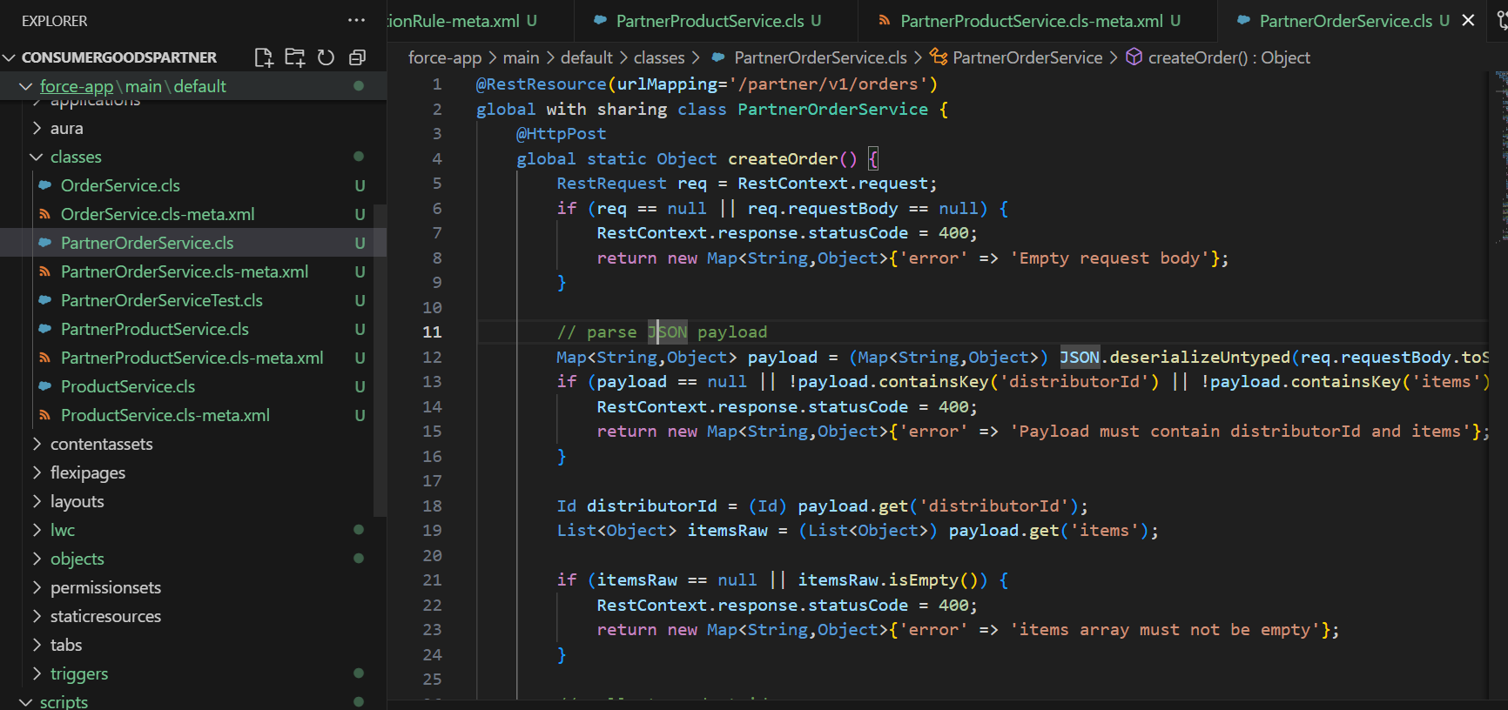
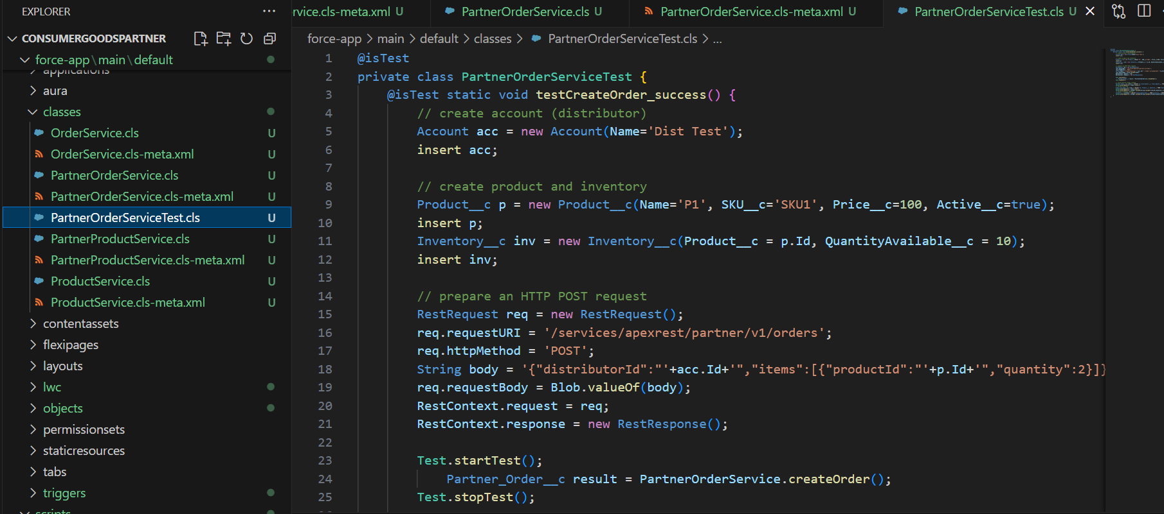
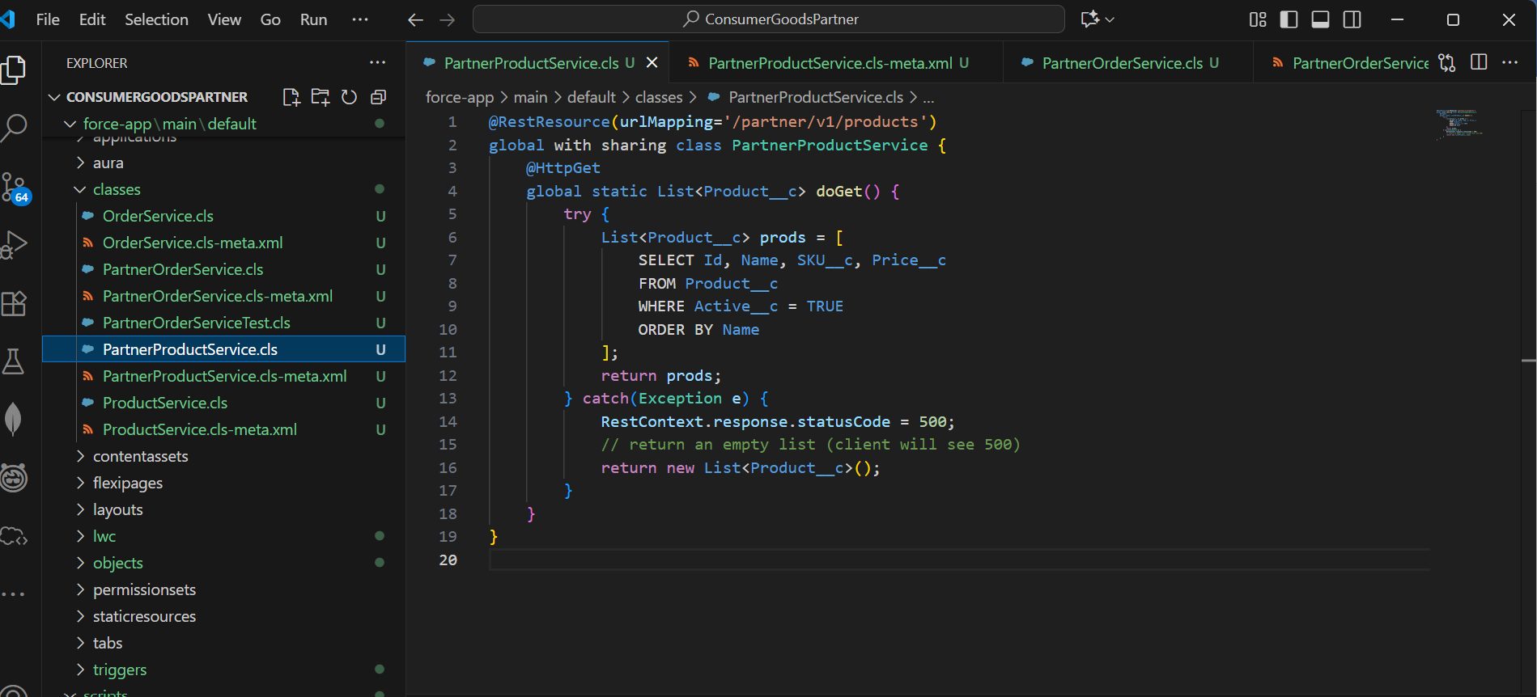
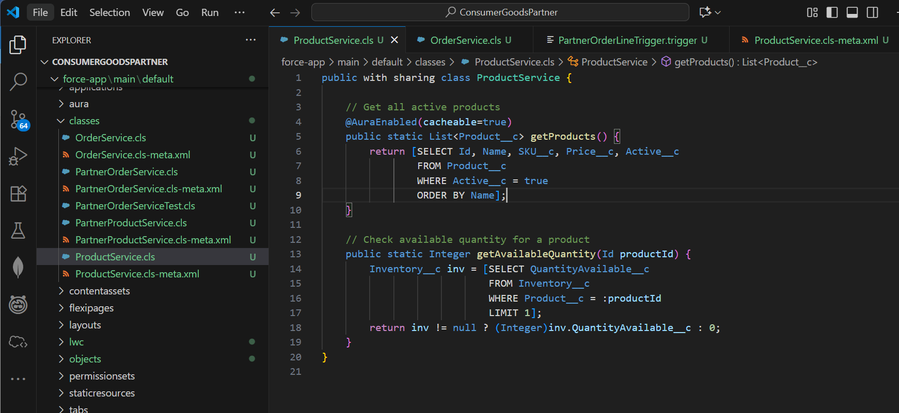

3. REST API Endpoint Example
Endpoint URL:
https://<your-dev-org>.lightning.force.com/services/apexrest/partner/v1/orders
Request JSON body:
{
"distributorId": "001gL00000P8auLQAR",
"items": [
{
"productId": "a07gL00000EiBURQA3",
"quantity": 5
}
]
}
- External systems can POST this payload to create partner orders automatically.
- Headers required:
  - Authorization: Bearer <ACCESS_TOKEN>
  - Content-Type: application/json

4. Apex Triggers
Order-Line Item Processing:
- Triggers were created to update inventory when a new order line item is inserted.
- Example: On insert of Order_Line_Item__c, the corresponding Inventory__c.QuantityAvailable__c is reduced.
- Handles bulk operations to comply with Salesforce governor limits.
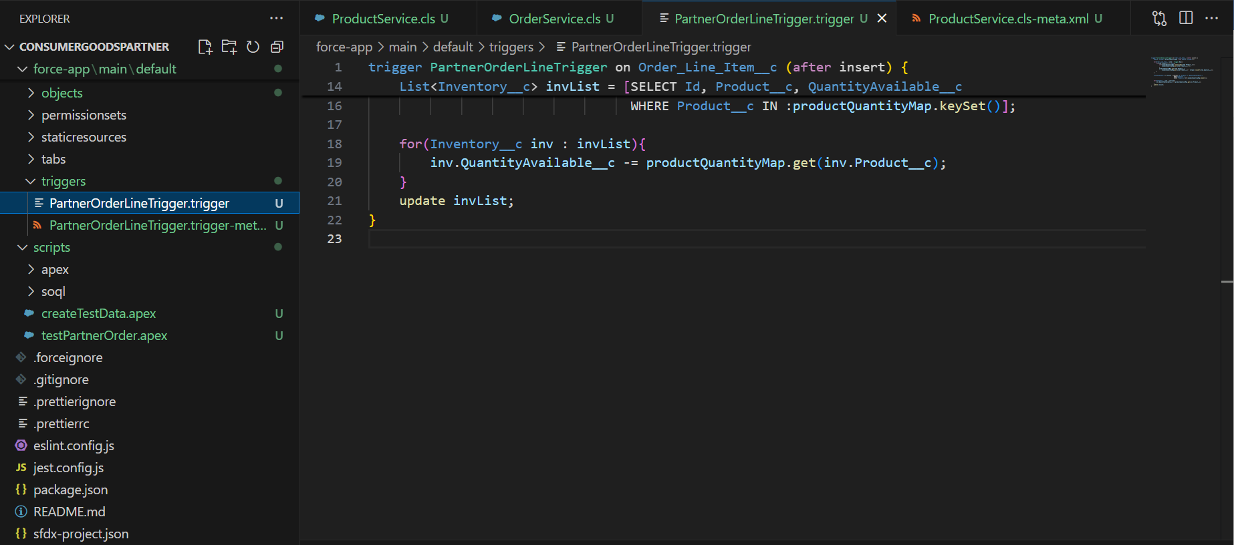

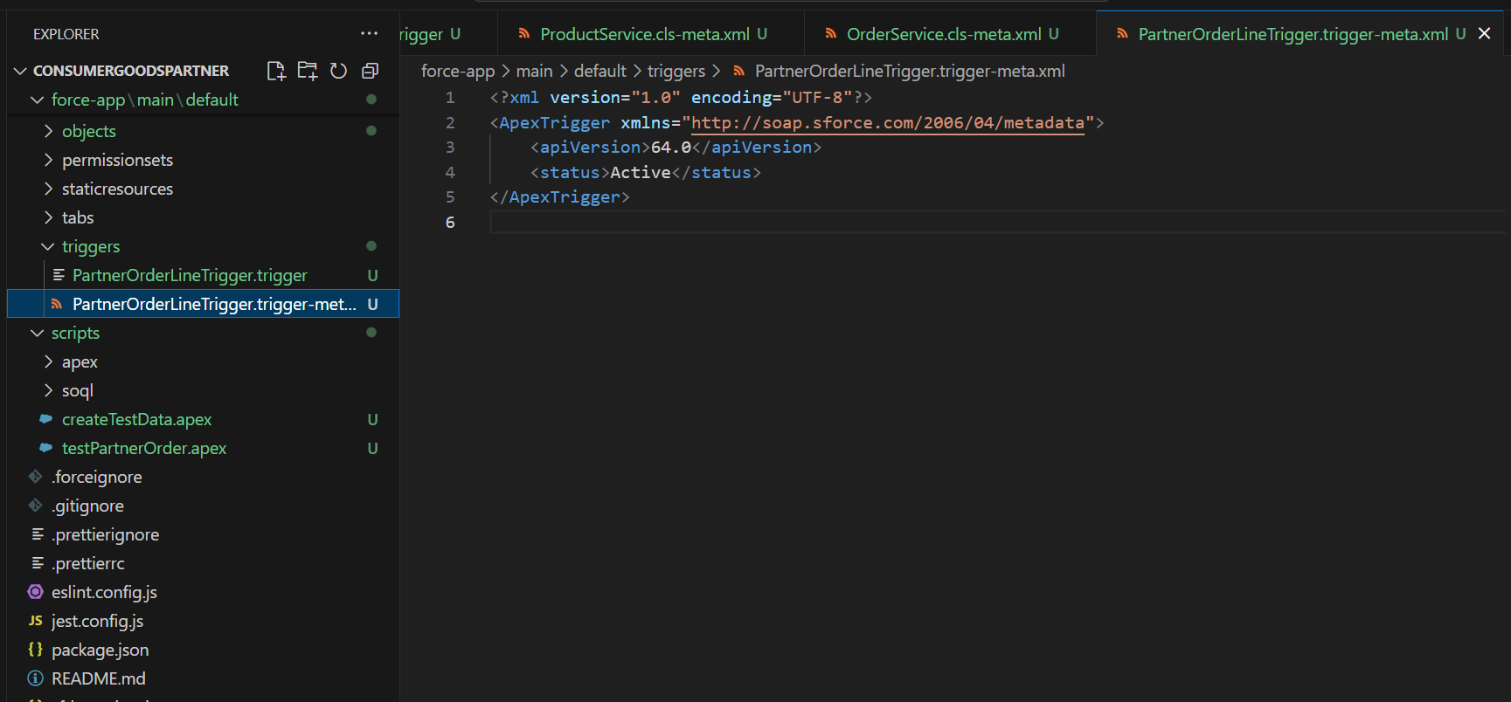

5. Test Data Creation
- Created anonymous Apex scripts to generate sample data for testing:
  - Distributor Account
  - Product__c records
  - Inventory__c records
Example Anonymous Apex Script:
Account a = new Account(Name='Distributor Test');
insert a;

Product__c p = new Product__c(Name='API Product 1', SKU__c='API-SKU-1', Price__c=150, Active__c=true);
insert p;

Inventory__c inv = new Inventory__c(Product__c = p.Id, QuantityAvailable__c = 20);
insert inv;

System.debug('DIST:' + a.Id + ' PROD:' + p.Id);
Screenshot Suggestion: VS Code → scripts folder → createTestData.apex.
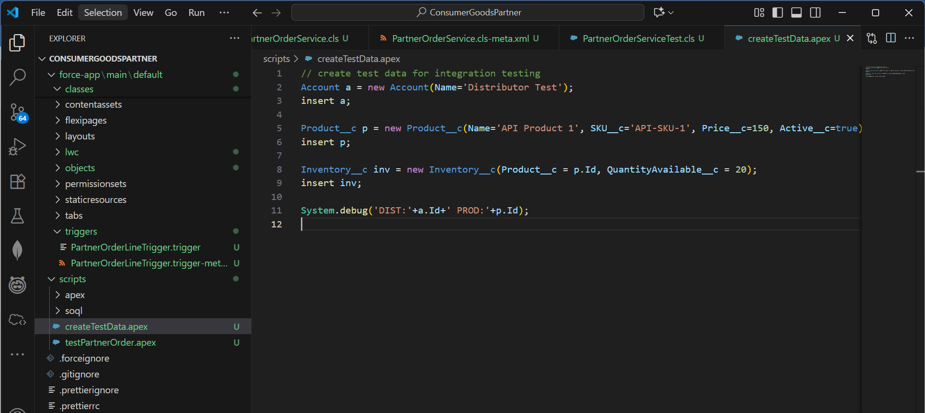

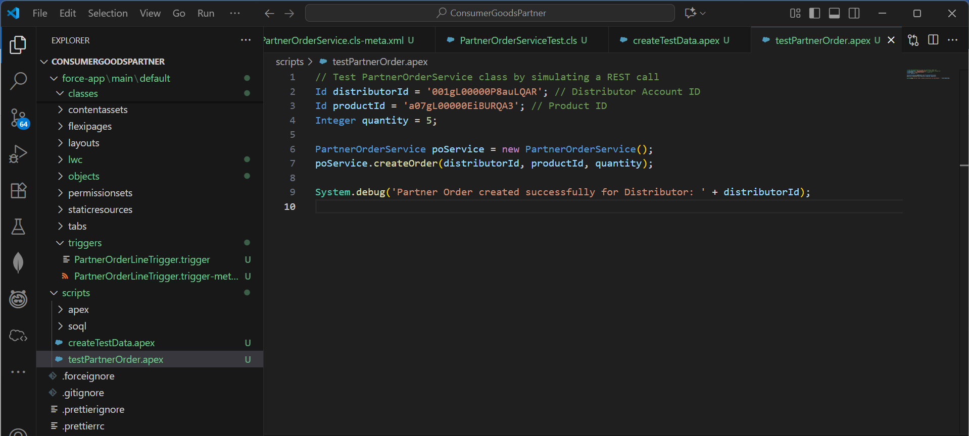

6. Executing Apex in VS Code
- Commands used to run anonymous Apex scripts:
# Execute script file
sf apex run --file scripts/createTestData.apex --target-org DevOrg
- Commands executed successfully created test data with IDs visible in debug logs.

7. Integration Testing
- Tested the PartnerOrderService REST API using Postman with the JSON payload.
- Verified response contains orderId and status code 201.
- Validated that Inventory__c.QuantityAvailable__c was updated correctly after order creation.

8. Exception Handling & Validation
- Apex code includes validation for:
  - Empty or invalid payloads.
  - Missing distributorId or items.
  - Non-existent products.
  - Insufficient inventory.
- Proper HTTP error codes (400) returned for invalid input.

9. Outcome of Phase 5
- Custom Apex classes successfully developed for orders and products.
- Triggers implemented to maintain inventory accuracy.
- Test data scripts created and executed in VS Code.
- REST API endpoints functional and tested with Postman.
- Validations and error handling implemented for robust integration.

